Wildlife Tracker Tool Installation Document

**Farheen Aslam**

# Contents

Contents 2

1. Introduction 3

1.1 Purpose and scope 3

2. Central DB AND server setup 3

2.1 Installation instructions 3

2.1.1 Prerequisite 3

2.2 DB setup 3

2.2.1 DB setup using MySQL WorkBench And Importing Schema 3

2.3 Deploying services in IIS 4

2.3.1 Installing IIS 4

2.3.2 Deploying Services in IIS 5

3. WILD LIFE TRACKER TOOL CLIENT SET UP 6

3.1 Installation instructions 6

3.1.1 Configuring Wildlife Tracker Tool Client 6

4. Doxygen for HTML Document 6

4.1 Installation instructions 6

4.1 Generating HTML Document 6

# Introduction

## Purpose and scope

This document contains the information for Wildlife Tracking Tool application Server and Client setup.

Note: This document outlines installation steps for first time setting up of central DB server.

# Central DB And Server setup

## Installation instructions

### Prerequisite

* OS: Windows 7 or above (both 32 bit &64 bit)
* .Net Framework 4 or above
* MySQL
* MySQL connector

## DB setup

### DB setup using MySQL WorkBench And Importing Schema

1. Download and install MySQL server and workbench .
2. Once MySQL is installed in the system, open MySQL Workbench, select the local instance and enter the credentials if prompted.
3. The SQL dump file will be provided named "**game\_reserve\_db.sql**" to set up DB for wildlife tracking tool.
4. Create a new schema named " **game\_reserve\_db** ".
5. Select Data Import option from Server>DataImport.
6. Select the "Import from Self-Contained file" option and browse to select the DB backup dump provided.
7. In the default Target Schema, select the schema name that is newly constructed.
8. Click Start Import button.
9. C:\Users\manus\Desktop\Document Images\connection_string.JPGRefresh the schemas at left hand side and the newly imported schema will be listed with all the tables and stored procedures. Update “connection string” setting in web.configfile. of Wildlife Tracker Service Change**username, password**and **Database**as shown below :

## Deploying services in IIS

### Installing IIS

1. In Windows, access the Control Panel and click **Programs.**
2. In the **Programs and Features** window, click **Turn Windows features on or off**.
3. Select the **Internet Information Services (IIS)** check box, expand the node andensure that the following items are selected.
4. Then click **OK**.
5. For the changes to take effect Restart PC

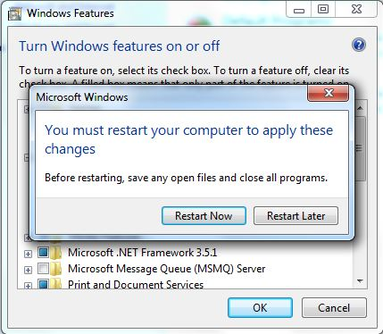

### Deploying Service in IIS

1. Open IIS by giving “inetmgr” in Run Window

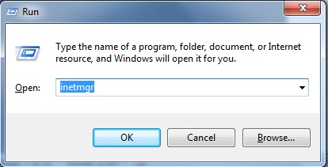

1. Once IIS is opened, Expand the nodes in **Connections** panel (in left hand side of the window), to reach **Default Web Site.**
2. Right Click **Default Web Site** and select **Add Application**.
3. In **Add Application** pop-up window, give the folder name as alias name. For example, while hosting WildLifeTracker web service, give the alias name as WildLifeTracker .
4. Browse the physical path to point to \Bin\ WildLifeTracker
5. Click OK to complete adding the application to IIS
6. **Service specific configurations are specified in “Web.config” file. This file has to manually edit in any note pad editor**
7. Test that the service is hosted correctly. Browse to Actions ->ManageApplication ->BrowseApplication. Press “Browse” option , this should open up a web browser as follows:

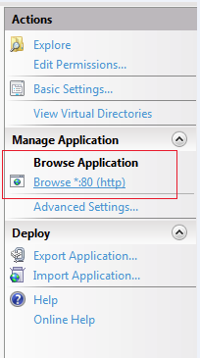

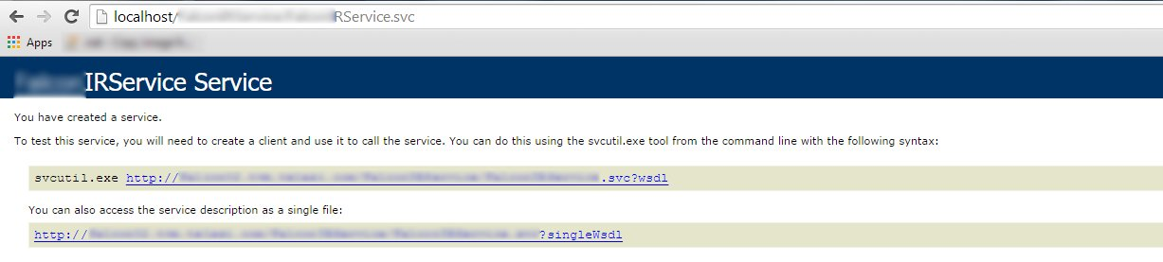

1. Note that the domain name is correct in service URL. This service URL is required for configuring the client application

# Wildlife Tracker Tool client setup

## Installation instructions

**Pre-requisites**:

OS: preferably Windows 7 or above

### Configuring WildlifeTracker Tool Client

1. Go to the Visual Studio and select the Release option from the drop down in the Main Menu. Change the " WildLifeTrackerServiceBaseURL " to newly hosted server URL in App.config.
2. On successfully building the application , .exe will be generated inside the Project folder under WildlifeTrackingApp\WildlifeTrackingApp\WildlifeTrackingApp\bin\Release\WildlifeTracking.exe.
3. Open WildlifeTrackingApp\WildlifeTrackingApp\WildlifeTrackingApp\bin\Release\WildlifeTrackingApp.exe.config in an editor to make any changes in the configuration.

# Installing Doxygen for HTML Documents

## Installation instructions

Download the doxygen and install it to generate the HTML documents.

## Generating HTML Documents

1. Open Doxygen GUI frontend.
2. Choose the Project Option from Wizard
3. Select the root folder of the application for which the document is to be generated.
4. Specify the Project Name to be displayed in the document.
5. Locate the source directory.
6. Specify the destination directory to which the document is to be saved.
7. Tick on "Scan recursively option".
8. Select Mode from Wizard Option.
9. Select "Optimize for Java or C# output".
10. Select Expert Option from Main Menu .
11. Select Build option from Expert and select the options for which the document is needed.
12. Choose Run from main menu and select "Run doxygen".
13. It generates the html document in destination directory.